

Practices for Secure Software Report

Table of Contents
Document Revision History 3
Client 3
Instructions 3
Developer 4
1. Algorithm Cipher 4
2. Certificate Generation 4
3. Deploy Cipher 4
4. Secure Communications 4
5. Secondary Testing 4
6. Functional Testing 4
7. Summary 4
8. Industry Standard Best Practices 4

Document Revision History

Version | Date | Author | Comments
1.0 | 06/23/2023 | Daniel Dobbs

Client



Instructions

Submit this completed practices for secure software report. Replace the bracketed text with the relevant information. You must document your process for writing secure communications and refactoring code that complies with software security testing protocols.

- Respond to the steps outlined below and include your findings.
- Respond using your own words. You may also choose to include images or supporting materials. If you include them, make certain to insert them in all the relevant locations in the document.
- Refer to the Project Two Guidelines and Rubric for more detailed instructions about each section of the template.

Developer
Daniel Dobbs

Algorithm Cipher

I would recommend deploying both the use of AES and SHA-256. AES can be used for data encryption at Artemis Financial. AES is fast and efficient at encrypting large amounts of data which is suitable for the sensitive financial data that Artemis deals with. AES is a symmetric encryption meaning that same key is used for both encrypting and decrypting data which means that both parties involved must have communication have the same key. SHA-256 is a cryptographic hash function which lets data be created into a hash when transmitting. This allows Artemis Financial to create a hash of the data they are sending when transmitting to make sure it does not get tampered with. By combing both AES encryption with SHA-256 hash verification, it address both confidentiality and integrity of the data, which are crucial aspects of information security.

Certificate Generation
Insert a screenshot below of the CER file.

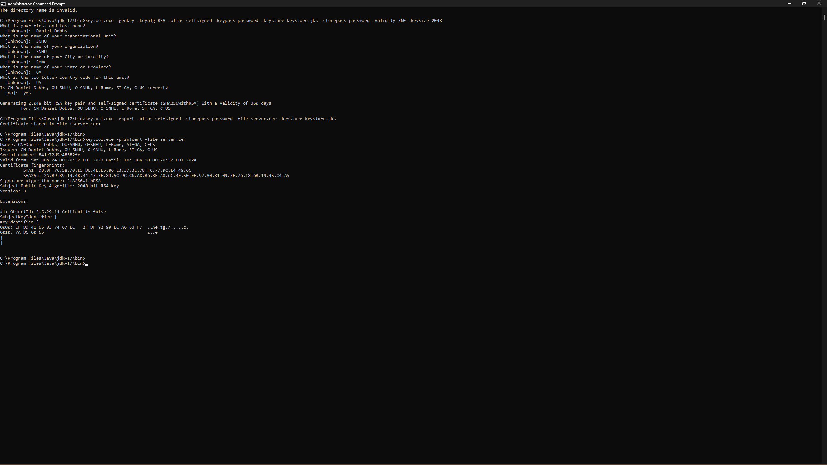

Deploy Cipher
Insert a screenshot below of the checksum verification.

Secure Communications
Insert a screenshot below of the web browser that shows a secure webpage.

The only reason it is saying not secure is because the key tool is self-signed.

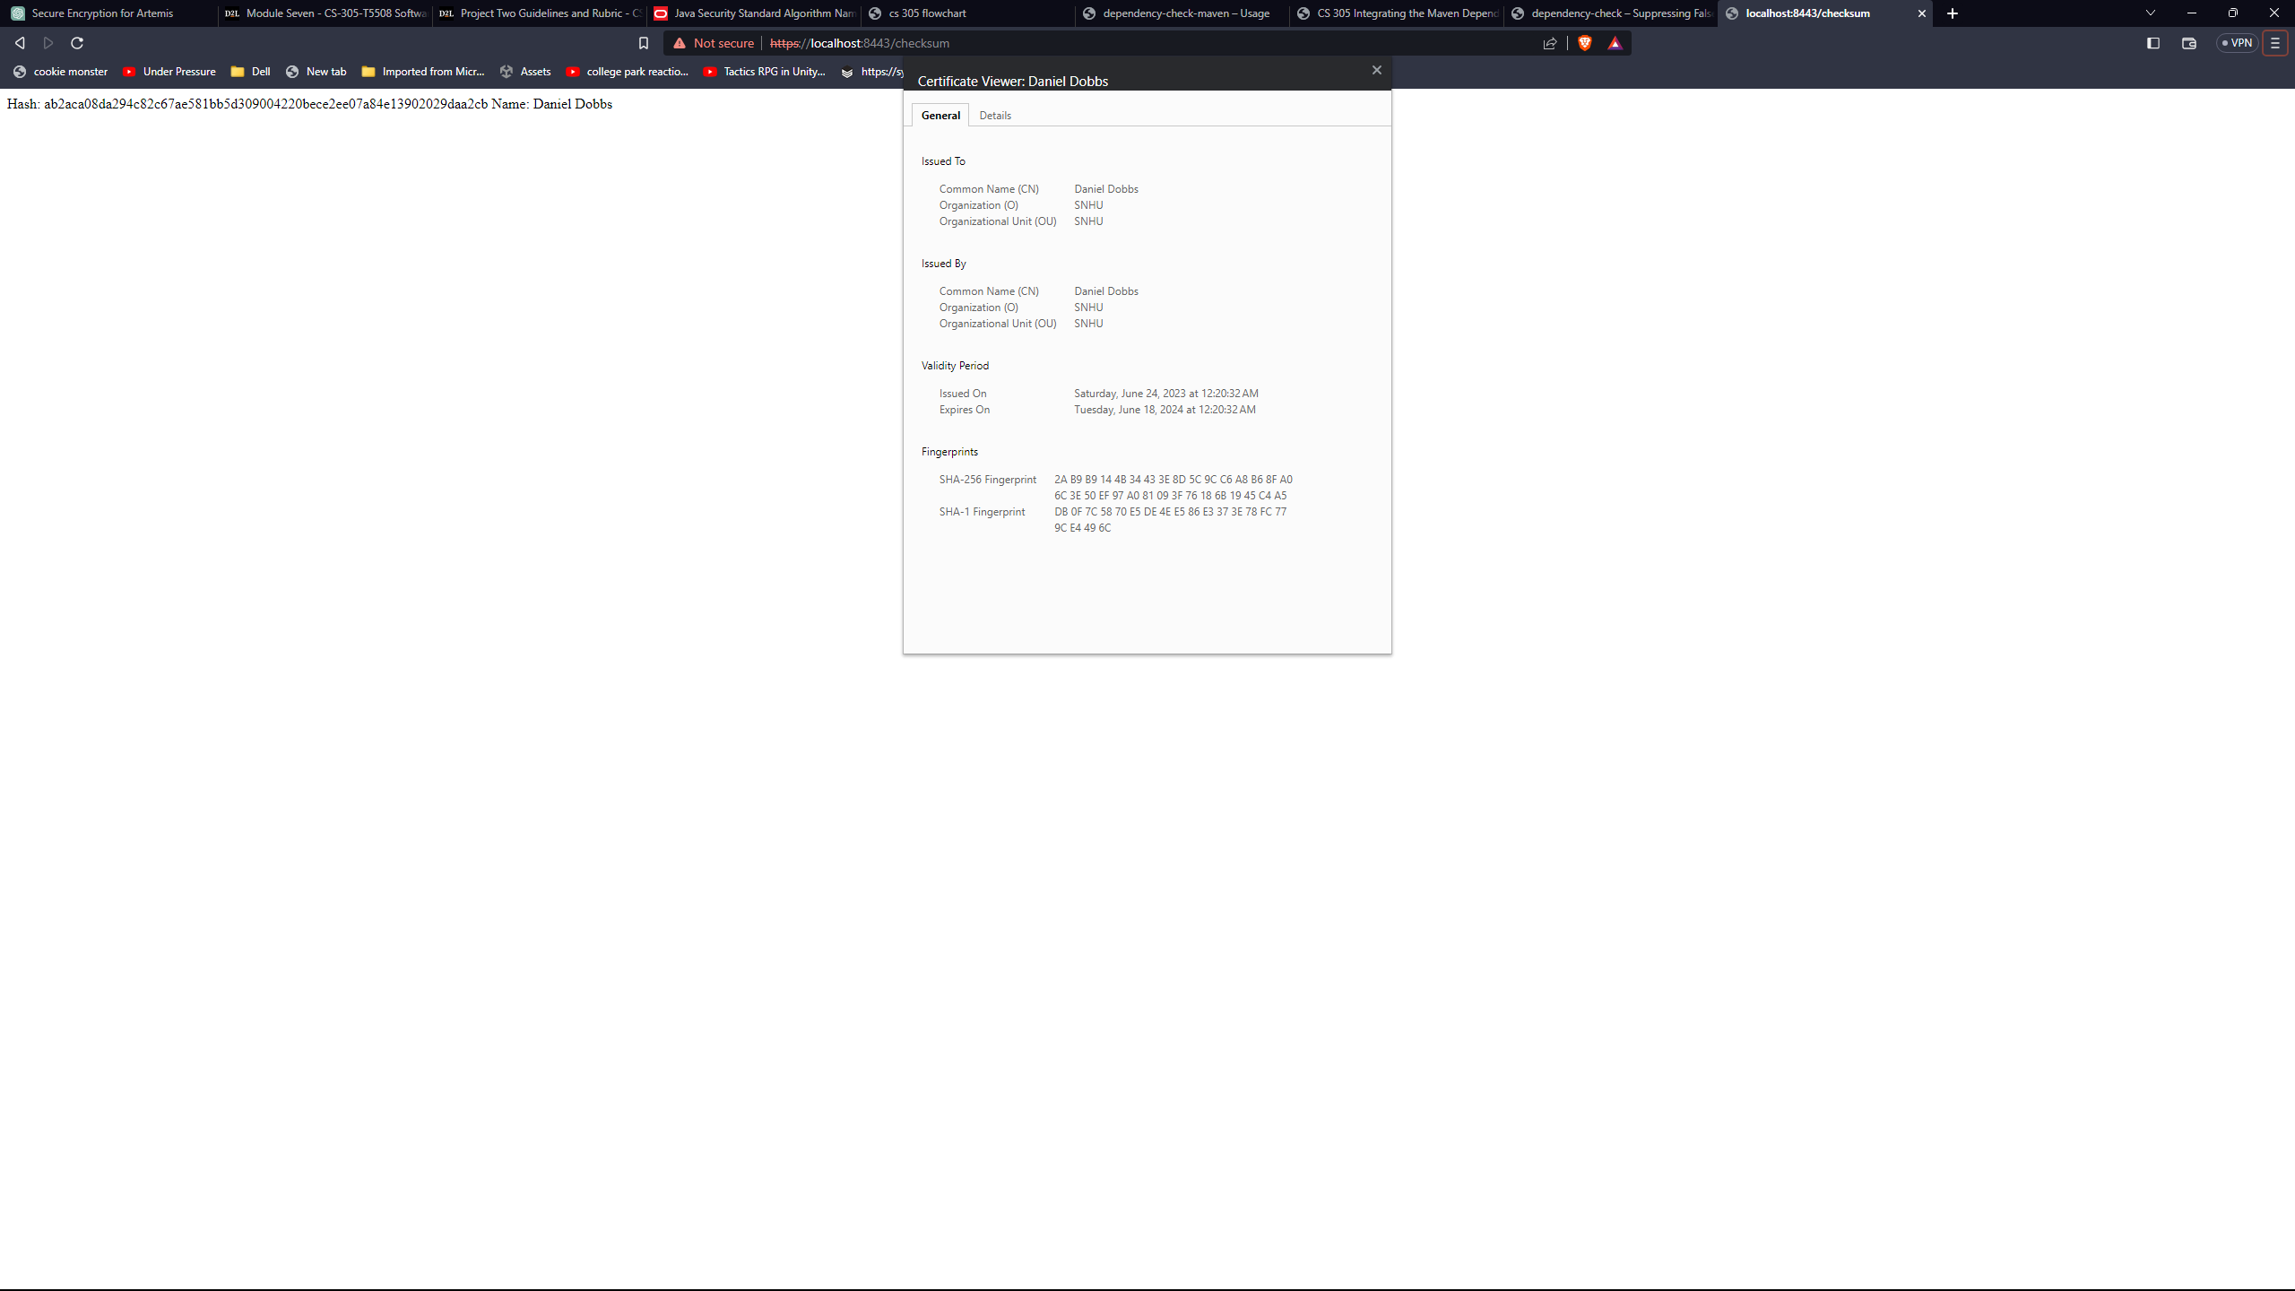

Secondary Testing
Insert screenshots below of the refactored code executed without errors and the dependency-check report.
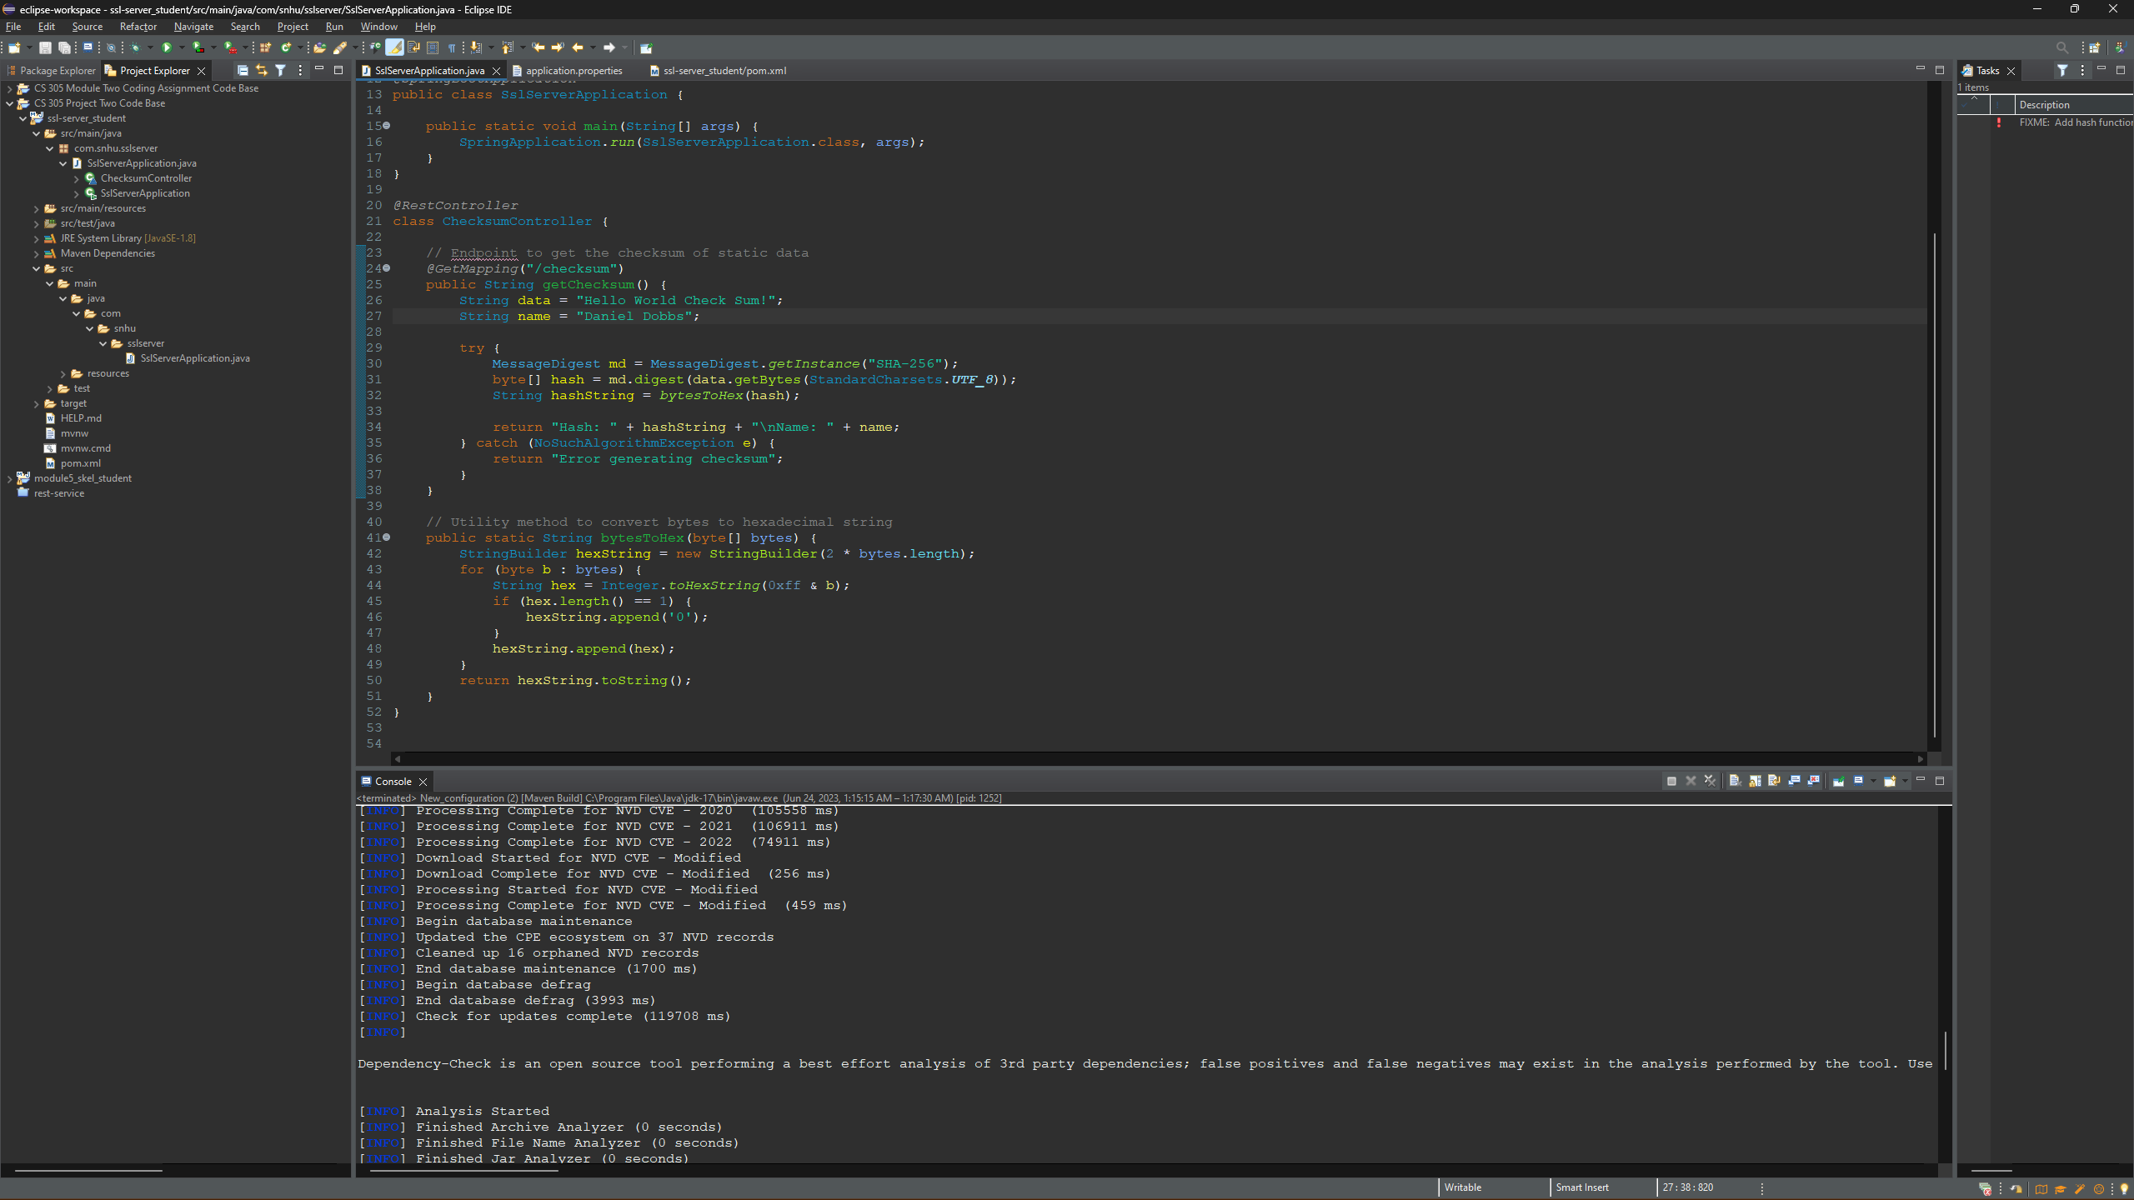
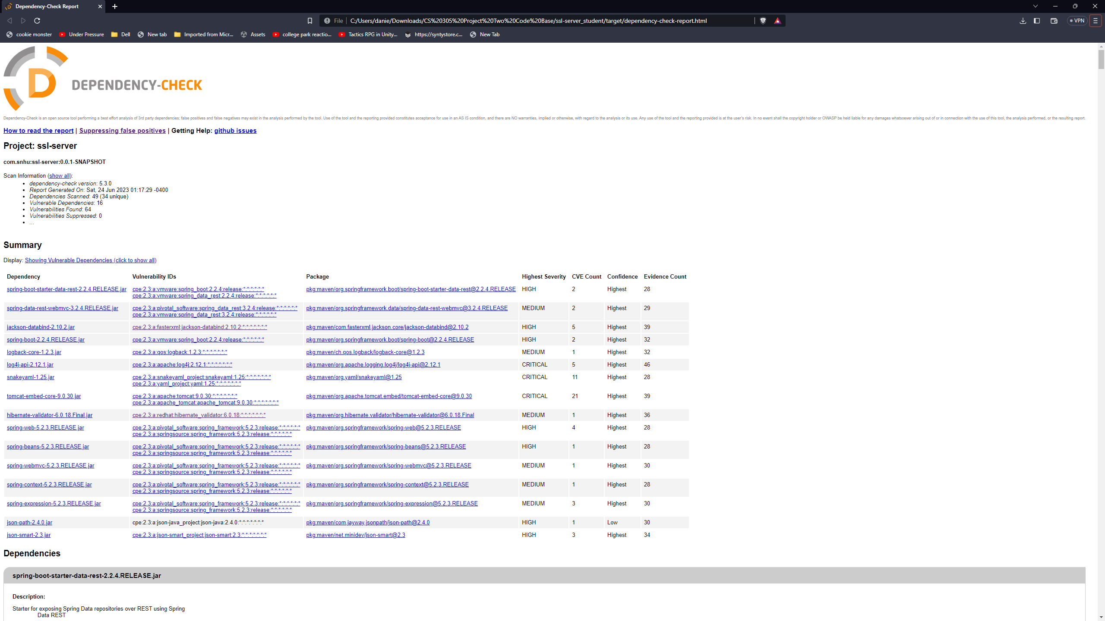

Functional Testing
Insert a screenshot below of the refactored code executed without errors.
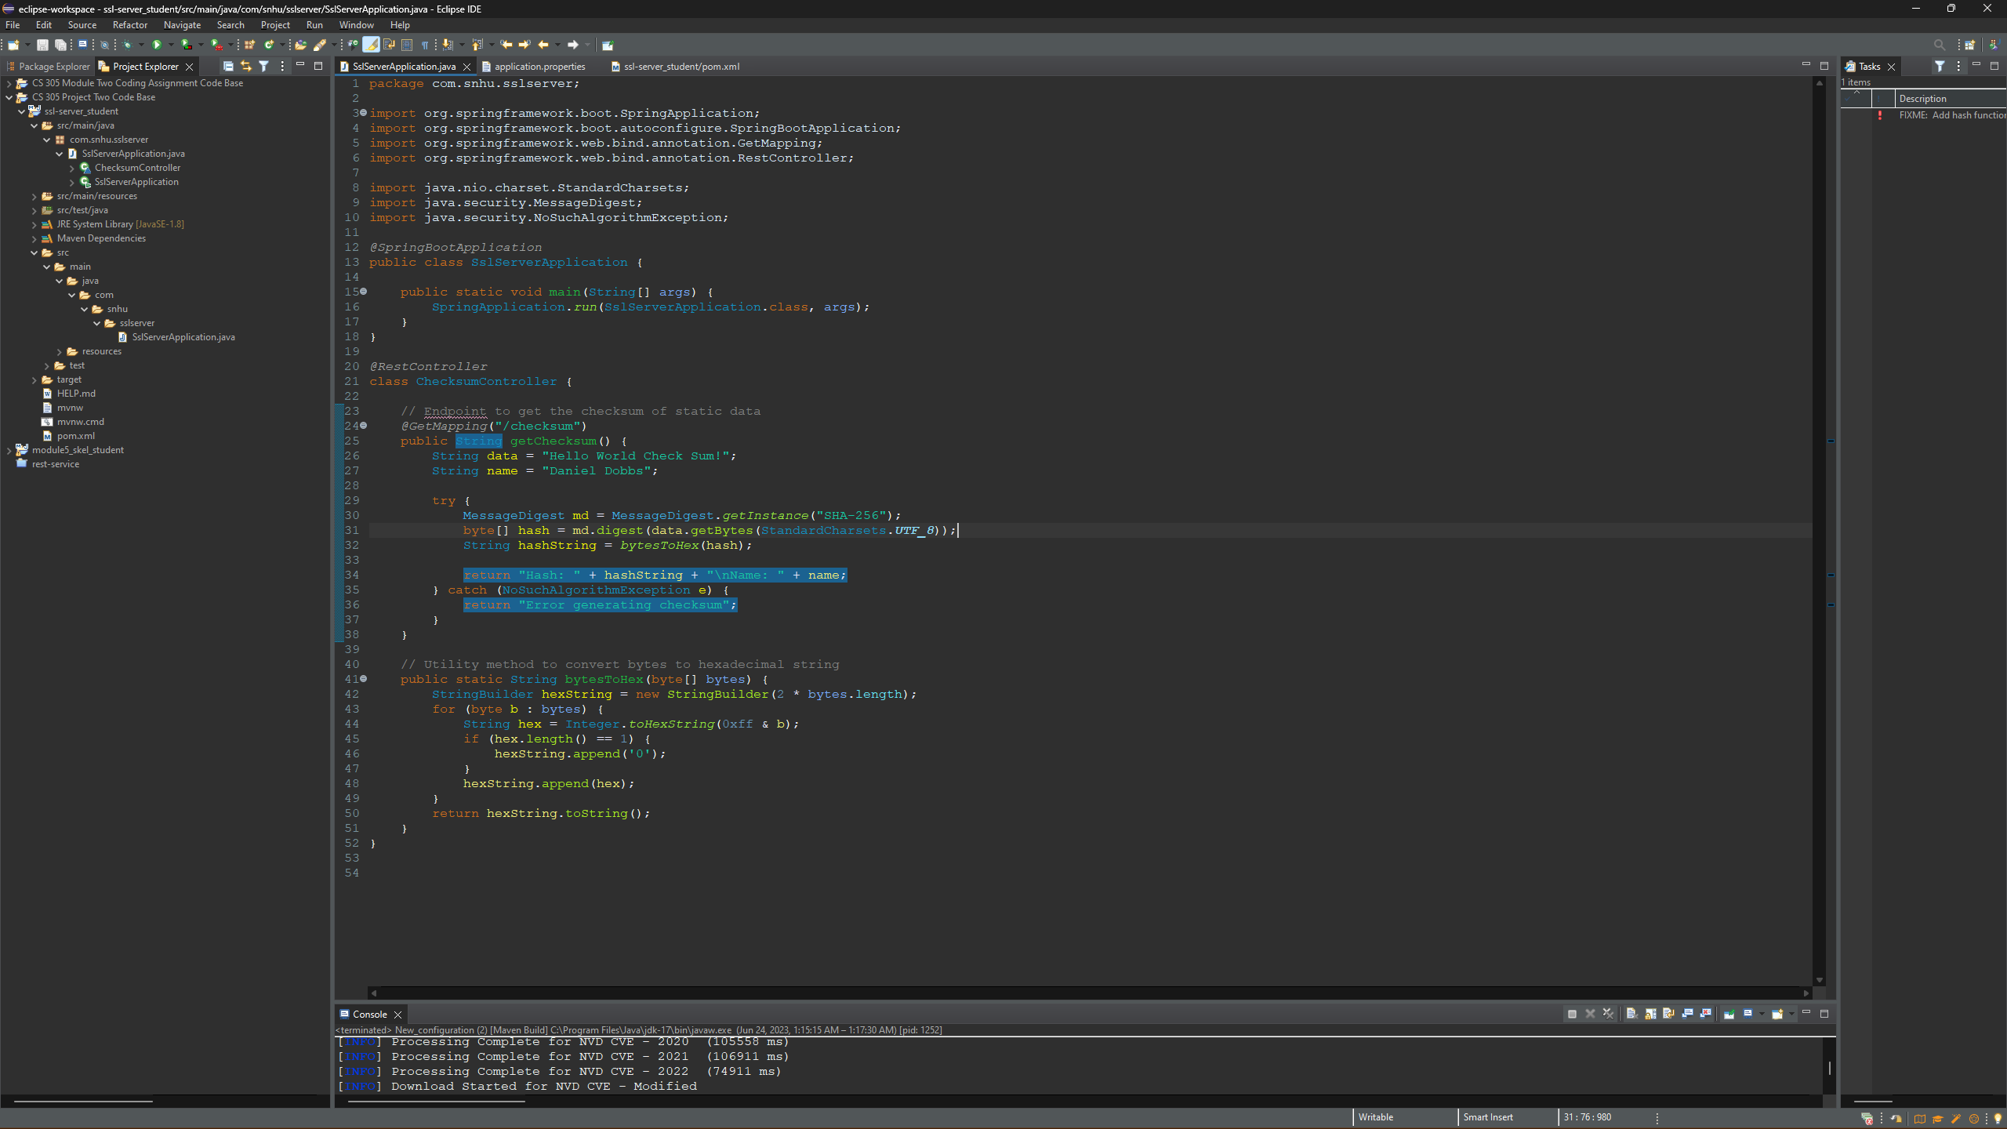

Summary

The refactored code was modified to use secure communication protocols such as HTTPS to encrypt the communication between the client and server. Input validation was added to ensure that user inputs and data from external sources are properly validated, and this helps prevent common security vulnerabilities such as SQL inject and XSS attacks. Proper error handling mechanisms were implemented to avoid exposing sensitive information to users. Generic error messages are used to prevent revealing implementation details or sensitive data that could aid attacks. The code uses SHA-256 for hashing which provides minimal collisions and can help cut down attacks. Access controls mechanisms were implemented to restrict access to sensitive resources and endpoints. Authentication and authorization techniques were used to ensure that only authorized users can access certain parts of the applications, prevent unauthorized access, and protect sensitive data. The refactoring processes followed a systematic approach making use of security best practices, secure coding guidelines, and vulnerability assessment methodologies. The code was carefully reviewed and tested to identify and address potential vulnerabilities. Through this iterative process, the software application was strength and made more resilient against security threats. For Artemis to maintain good security they should do regular dependency checks and make sure all plugins and spring stay updated to insure they have the latest security patches to cut down on vulnerabilities.

Industry Standard Best Practices

The practices of OWASP were followed for writing secure code in this environment. This includes proper input validation, secure session management, secure error handling, and secure configuration management. By following established best practices, the software application is fortified against known security vulnerability which in turn reduces the risk of security breaches and data leaks. Also, it helps compliance with regulations, security regulations and frameworks. Best practices also help protect sensitive data by implementing proper encryption, access control, and secure data handling. Also following best practices can reduce development costs by cutting the likelihood of costly security incidents in the future. A secure position in the company gives a competitive advantage by instilling confidence in customers and partners and demonstrates a commitment to data protection, privacy, and security. In conclusion, applying industry standard best practices for secure coding helps maintain the software application’s current security and contributes to the overall well-being of the company. It mitigates security risks, ensures compliance, protects sensitive information, reduces costs, and helps maintain a competitive edge in the market.

